Greetings!

Topics:
- Preparation period
- Completion of the training contract
- Practical part: During the mobility
- Recognition process
- Visa
- Insurance
- Scholarship
- Place of residence
- Utility services
- Public transport
- ESN
- Tickets
- Before departure
- Problems
- Frequently Asked Questions/What you need to know

This document is a "Study Kit" that will help you complete your Learning Agreement and answer frequently asked questions.

Preparation period:
After submitting the candidacy by the Georgian American University, the student should wait for the receiving university's email, in some cases the Georgian American University itself sends the response of the receiving university.
• If no one has contacted the student within 3 weeks after submitting the candidacy, he should send an email to the international relations office of the Georgian American University - anarveladze@gau.edu.ge and inform about the mentioned situation.
If a positive response is received from the host university, communication with them begins. The receiving university sends the student information about the list of subjects, grant agreement, accommodation, etc. Therefore, in case of questions, the student should contact the host university. In case of a delay in the response, the student should contact the International Relations Office at the email indicated above.
In addition, in case of desire for advice and consultation during the preparation period, the student can visit the International Relations Office of GAU and receive relevant information.
• Students should take into account that office reception hours are set - Monday - from 11:00 to 19:00, Thursday: from 13:30 to 19:00 (it is not necessary to book a visit in advance during these times).
At other times, prior appointment is necessary.
You can schedule a visit by e-mail: anarveladze@gau.edu.ge or by calling the indicated number - 514 891 515. Office number: (+995 32) 220 65 20 (330).

Filling out the training contract:
The student must complete the study contract.
This requires a list of subjects that the host university offers to the student. The said list can be checked on the website of the receiving university (sometimes there is no updated list). Also, the student can contact the receiving university by e-mail and ask for a list of subjects (in case of a late response, please contact the International Relations Office of the Georgian American University).
After that, in agreement with the faculty (necessary!) the study contract is filled out. The completed agreement is sent to the International Relations Office of GAU for signing (at the above email), and then to the host university (put Georgian American University in the CC) so that the responsible person of the host university can also sign.
• The student should take into account that when sending the contract to the international relations office, he should indicate in the email: "The mentioned subjects (provided by the study contract) have been agreed with the faculty". Otherwise, the representative of the International Relations Office cannot sign the contract.
• Also, in case of the need to sign the study contract, the said document should be sent to the International Office of GAU one week before the deadline (before sending it to the host university).
Along with the announcement of the competition, the form of the training contract will be published on the website. On the first page, the student is required to fill in information about the sending university. Along with the student's data (name, surname, university, faculty, etc.), the information of the Georgian American University is filled in The sending institution, along with the contact person name, the information of Tamara Mechurchlishvili (Head of the Department of International Relations) should be filled in. Contact information - Office: (+995 32) 220 65 20 (317), t.mechurchlishvili@gau.edu.ge)) . The field of Erasmus code of both institutions (sender and recipient) remains empty. In The receiving institution, the information of the receiving university is filled (address, faculty, responsible person, etc. - this information can be obtained through Google). In "Field of Education" the student indicates the name of the faculty at which he studies at the Georgian American University.
In addition, in the upper right corner (in the blue part), the student must indicate the name of the university (Higher Education) – Georgian American University LLC, the student's name, surname and academic year (in which year he/she is benefiting from the exchange).
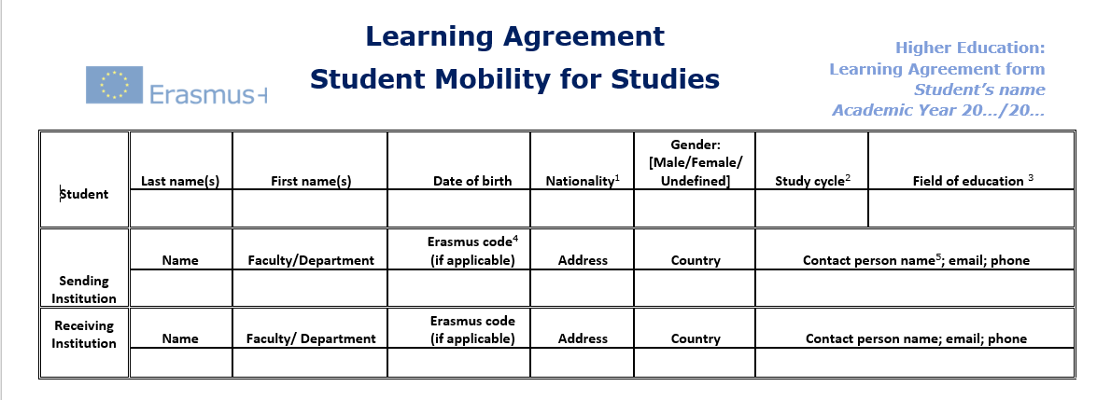

The next column "Before the mobility" is divided into two parts. To complete the first section (receiving institution) - the student must contact the faculty representative (academic manager) and choose subjects in agreement with him. Subjects are chosen according to the supervisor's opinion, so that there will be no problem with the recognition of credits in the future. Names of said subjects should be recorded in Table A, along with subject code (if any), mobility semester (departure period) (fall or spring) and number of credits. At the end, the credits are summed up (each subject must indicate the number of credits awarded at the receiving university - only when filling in Table A), the total number of credits is written in the "Total" section.
The student should not miss "Table A" - the upper part of the graph - "Planned Period of the mobility from....to" - period of mobility, eg: 02/2023 to 06/2023 inclusive. The lower column of "Table A" should also indicate the language competence (Level of English Competence) and the level (B2, C1).
In the next column (Recognition at the sending institution), the subjects for which the student will receive credit upon arrival in Georgia should be written (in the credits column, the number that will be assigned to the subject at the Georgian American University should be indicated, for example: subject "x" at the receiving university is 3 credit, and GAU may be considered a 4-credit subject, therefore, 4 credits are written in the credits column of "Table B". This part should also be filled based on the agreement with the academic manager (faculty). This document is filled in English. The total number of credits should be entered in the "Total" section.
After that, the student fills in his/her data in the "student" section, signs (electronically or can attach a scanned version) and sends it to GAU's International Relations Office for signature. It is best to send the file as a Word document. - When sending the document, it must be indicated that the mentioned subjects have been agreed with the academic manager (faculty). After the signature of the representative of the international office, the said document is sent (by the student) to the receiving university (to avoid confusion, it is better to put GAU international office in the CC of the email) for them to sign as well.
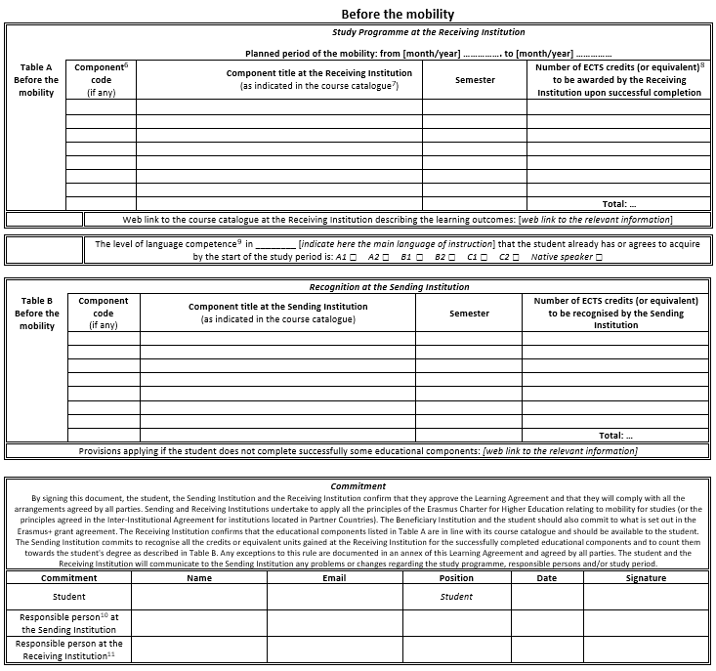

Practical part: During the mobility
The student has about five weeks after arriving at the receiving university to make changes to the study contract, which he indicates in the "during the mobility" section. Changes must again be agreed with the student's faculty (academic manager) and then sent to the GAU International Office for signature. The email must state that the changes have been agreed with the faculty.
In the During the mobility section (Table A2), the student enters the name of the subject, indicates the corresponding symbol next to it (deletes or adds this subject), and also indicates the reason for the change and the credit from the list. After that, he signs (since the column is not specified, he can add it himself, or electronically indicate the same information that he indicated in the upper columns when signing his signature).
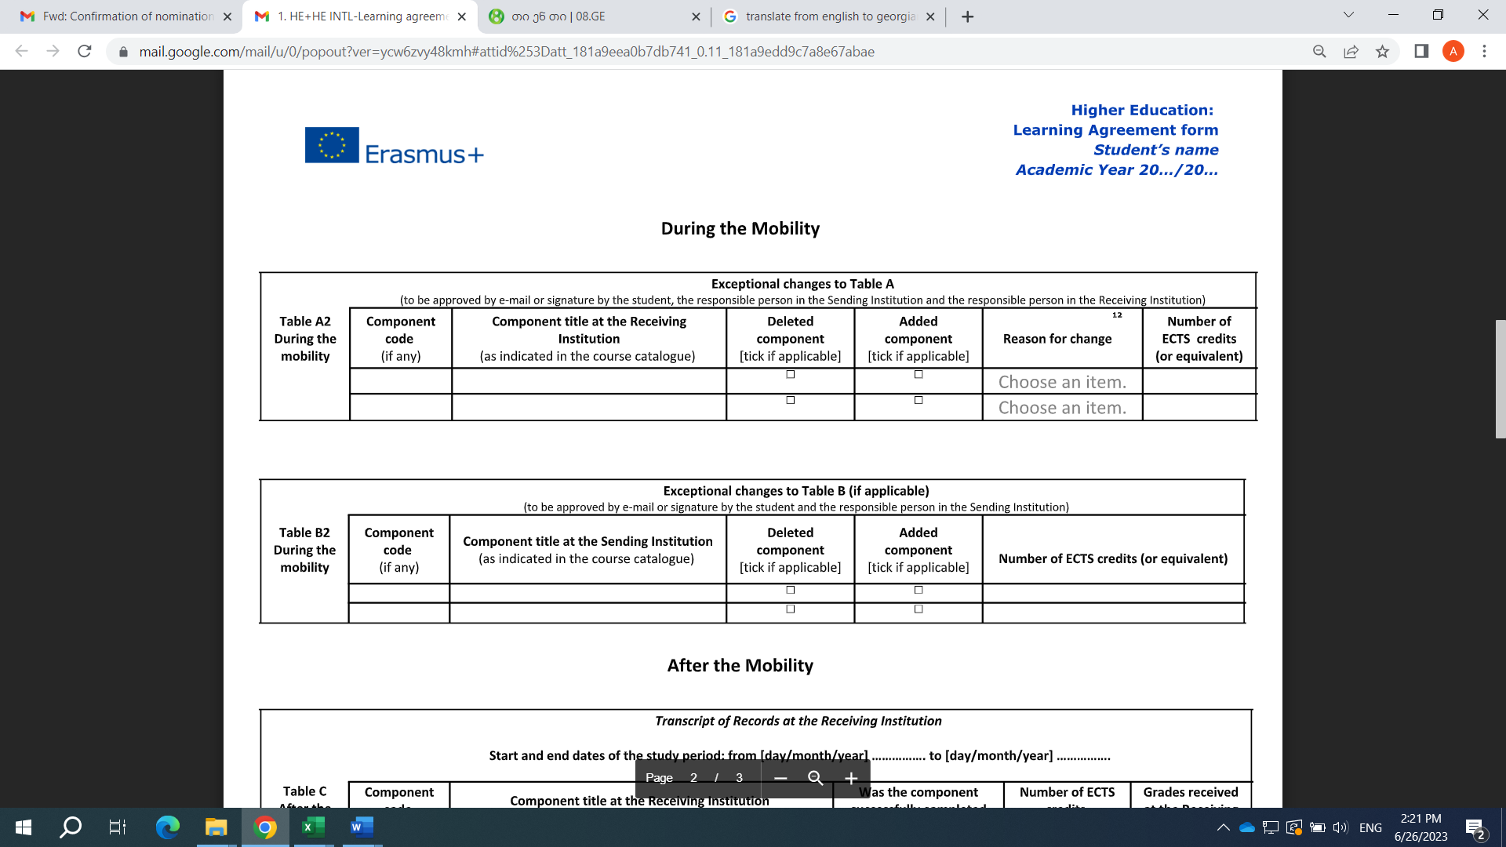
After the end of the exchange semester, the Georgian American University will receive the student's mark sheet electronically (it will also be sent to the student in parallel). If a student does not receive a mark sheet within approximately 3 weeks of the end of the exchange semester, they should contact the GAU International Relations Office. With the mark sheet, the student must visit the academic manager of his faculty to be given a certificate of compatibility, and then, with both documents (the mark sheet must be translated into Georgian and notarized), he must apply to the National Center for the Development of Education Quality for recognition of credits.
Address of the National Center for Education Quality Development: Merab Aleksidze Street, second lane N 2
+995 322 200 220 (*3599) postal code: 0193
info@eqe.ge

Recognition procedure:
The student is required to translate the official letter (mark sheet sent by the receiving university) into Georgian and notarize it. With the "Certificate of Compatibility" received from the faculty (from the academic manager) at the Georgian American University and the notarized mark sheet translated into Georgian, the student should go to the National Center for the Development of the Quality of Education and begin the process of credit recognition. Credits are recognized within one month after submitting the necessary documents. The student must submit the recognized documents to the academic manager of the relevant faculty of the Georgian American University.
The student should take into account that the National Center for the Development of the Quality of Education has established a credit recognition fee.

Visa
The only cost not covered by the Erasmus + ICM program is the visa fee. However, the GAU representative provides the student with a document from the National Erasmus Office and the European Commission stating that the person in question is exempt from the visa fee as an Erasmus participant. Unfortunately, some embassies (such as Italy, Belgium) continue to collect fees without taking this into account (in this case, Georgian American University cannot help you).
On the other hand, it is important for students to know that some embassies are not in Georgia, therefore under Turkish jurisdiction, such as the Spanish embassy in Istanbul, the Belgian embassy in Istanbul and Ankara, the Portuguese embassy in Ankara, etc. . It is possible to send documents by post (for example, to the Portuguese embassy). However, sometimes and most of the time, arrival is required (eg, Spain). (Please contact the embassy for updated information, the information mentioned in this document (regarding the visa) may change, and it is only a recommendation).

Insurance
Insurance is required to obtain a visa for exchange students. Some universities (such as Beja Polytechnic University) cover the cost of the student's insurance, but this does not apply to all universities, so the student should find out what kind of insurance the host country accepts in such cases (it is best to check with the host university). It is recommended that the student purchase host country insurance.

Scholarship:
The scholarship can be received after arrival in the host country (the scholarship can be given to the student monthly, as well as 50% or 70% at the start), therefore, the student must be able to allocate the scholarship correctly - be able to pay for the apartment rent, taxes, etc. The student will receive the stipend within a month of arrival, and the remainder a few days before departure (depending on the host university, they will distribute the stipend).
There are several options for receiving the scholarship: to be charged to a Georgian card (although in this case a commission may be deducted), in the form of a check (cash) (depending on the university) or to be charged to a bank card opened in the host country. The type of settlement is decided by the host university.

Dwelling Place
The student has the opportunity to choose his own accommodation. Some universities offer a residential campus, but not all, so it is best to check this information with the host university. A student can rent a room or an apartment (preferably close to a bus or subway stop, if in a metropolis, or in the center). It is necessary to conclude a contract with the owner of the apartment in order to avoid any unforeseen problems.

Utility Services
Depending on the contract, utilities may be added or subtracted from the rent. Before signing the contract, the student should read the contract carefully.

Public Transport
GAU International Relations Office advises students to take the so-called a monthly pass that will significantly reduce costs. The student may be eligible for student discounts, which he can check with the host university.

ESN:
Erasmus Student Network (ESN)

It is recommended that the student register for ESN in the city where he will spend the semester. After registration, you will be able to participate in many events and social/cultural activities with the received card. You will also receive a discount on Ryanair flights.
ESN often organizes trips and various student events. Students should note that the name of the said organization may differ in different countries.

Tickets
The ticket price (depending on the distance) is covered by the European Commission. The student buys the tickets (at his own expense) before the flight, a certain amount will be charged a few weeks after his arrival in the host country. (It is necessary for the student to keep the flight confirmation document - Boarding Pass). When announcing the competition, the amount of money allocated for tickets will be indicated.

Before Departure
It is recommended that the student take a certain amount of money with him (enough for about one month), because receiving the first scholarship may be delayed. In addition, it is recommended that the student clarify administrative issues (visiting the immigration office, obtaining a residence permit, enrolling in the university, etc.) at least one week before (before the start of the university).

Problems:
If there is a problem, the student should contact the international relations office of the host university. If the student is still unable to solve the problem, he should contact the International Relations Department of GAU in a timely manner: anarveladze@gau.edu.ge.

What you need to know:
• The student will have to return the Erasmus scholarship if he/she stops the mobility (i.e. ends/terminates the exchange) in less than 3 months.
• If the student is going to Spain, then he should contact the mentioned email - anarveladze@gau.edu.ge and be added to the Spain Erasmus chat ("messenger" is a platform, therefore, if the student wants to be added, he should also attach a Facebook profile link to the email), where all students gather, who was with Erasmus/ or goes from GAU to Spain.
• The subjects chosen by the student may not be open at the receiving university, they may coincide with each other, etc. (for various reasons), in this case the student chooses new subjects and changes the study contract. It may happen that English-friendly subjects are opened (the international office will warn the student about this in advance and they will mention it during the interview), which means that the study material will be delivered to the student in English, and the exams will be conducted in English. If the student has a problem with any of the professors in this regard (for example: he did not provide the English-language material on time, then he must contact the international office of the receiving university so that the professor can be warned in time and the study material can be provided). If the problem is still not resolved, the student should contact the Office of International Relations of the Georgian American University.

Questions:
• Which office of the Georgian American University manages the Erasmus+ international credit mobility program?
Department of International Relations
Third floor, room 305
anarveladze@gau.edu.ge
• Are there informational meetings about the proposals within the Erasmus+ program?
The Georgian American University conducts these meetings three times a semester, about which the student will receive a text message.
• Where can we get information about exchange programs at the Georgian American University?
On the website of the Department of International Relations of the Georgian American University and on the FB page of the Georgian American University (https://www.facebook.com/GeorgianAmericanUniversity)
• What is the maximum duration for which I can use Erasmus?
Minimum 2 (in case of internship), and maximum 12 months (although only at one level of education).
• Which level of students can participate?
Undergraduate - 2nd, 3rd, 4th, 5th, 6th (this means bringing in applications), as for leaving - 3rd, 4th, 5th, 6th, 6th Available for 7th semester students.
Master's degree - 1st, 2nd
Doctorate - 1st, 2nd, 3rd, 4th.
• How much is the monthly scholarship given within Erasmus?
The grant depends on which host country the student is traveling to (800, 850 or 900 euros).
Group 1 – 900 euros
Group 2 – 850 euros
Group 3 – 800 euros

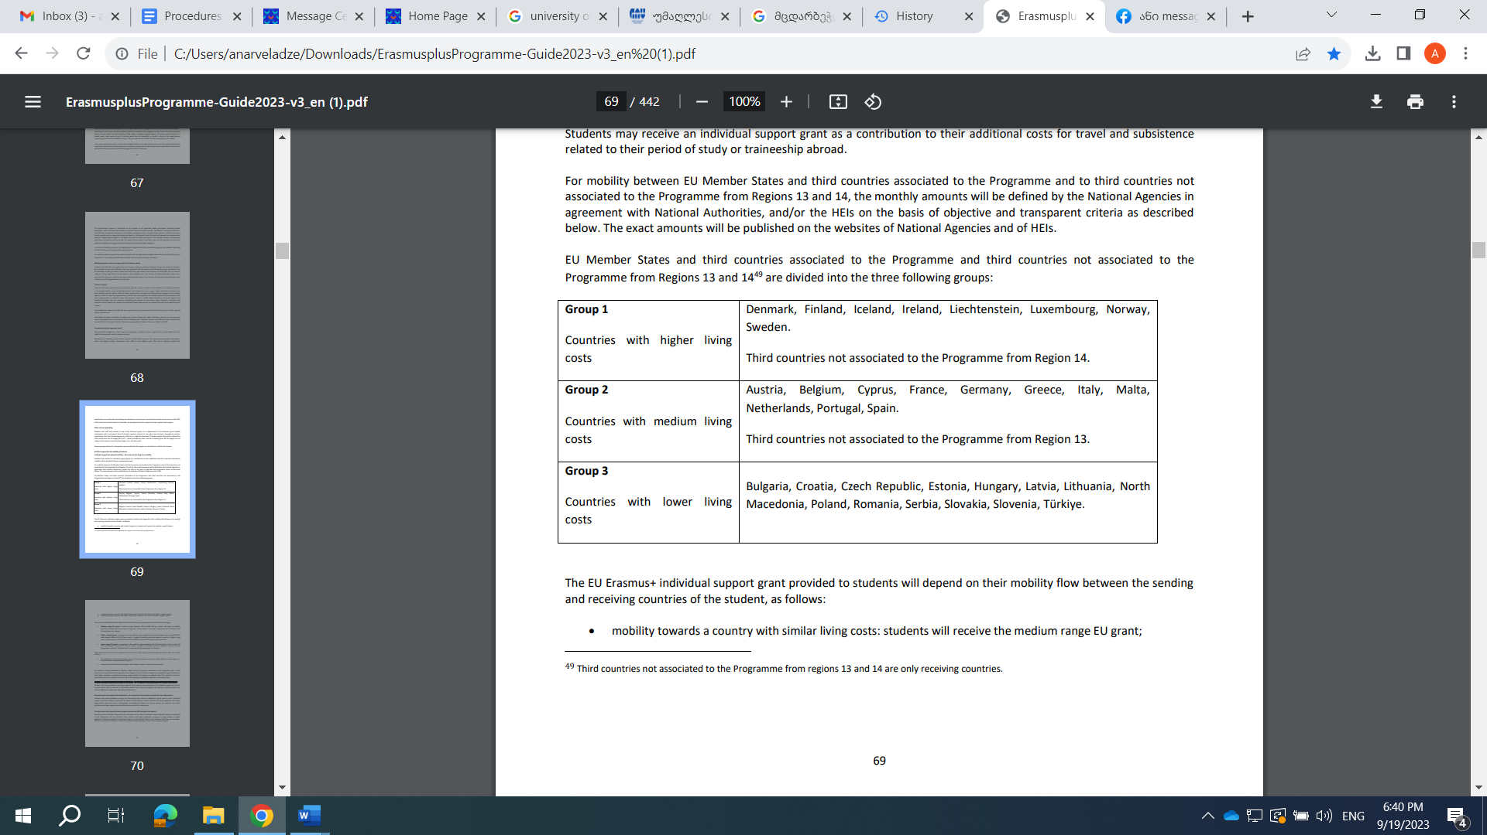
- How do I determine the amount allocated for round-trip international travel?
The student can calculate the cost of the trip using a special calculator: http://ec.europa.eu/dgs/education_culture/tools/distance_en.htm
And then be guided by the following:
- 10-99 km: 23 euros
- 100 - 499 km: 180 euros
- 500 - 1999 km: 275 euros
- 2000 – 2999 km: 360 euros
- 3000 - 3999 km: 530 euros
- 4000 - 7999 km: 820 euros

What documents do I need to apply for an exchange program?
List of application documents for students:
• Biometric passport copy;
• European CV format (in English, no more than two pages);
• Notice of student status (official document in English);
• extract of university marks (official document in English);
• English language certificate/another language may be written in the request, depending on the exchange program (international certificate, or a certificate confirming knowledge of a subject passed in GAU, at least B2 level);
• Dean's recommendation (in the case of the School of Law, Social Sciences and Diplomacy, as well as the School of Humanities and Liberal Education. (Requirements may be added (depending on the exchange university and country)).
• How many universities can we apply to?
A student can apply for only 3 exchanges at a time.
• What happens if I don't have a passport/or I can't submit it within the given period?
If the student is unable to submit the passport by the last day of application, he/she can submit a certificate from the House of Justice that he/she has submitted an application for the preparation of a passport. However, the student should take into account that if his candidacy is selected, he will definitely have to make a passport in an accelerated manner.
• Where can I find information about subjects at the host university?
on the website of the host university.
• Can I extend the scholarship?
There is no automatic extension of the scholarship. However, the student can reapply and go through the selection stages.

Good luck!

